**DAILY ONLINE ACTIVITIES SUMMARY**

|  |  |  |  |  |  |  |  |  |
| --- | --- | --- | --- | --- | --- | --- | --- | --- |
| **Date:** | **22/07/2020** | | | | | **Name:** | **NIKHIL KUMAR** | |
| **Sem & Sec** | **4thSEM. & ‘B’ SEC.** | | | | | **USN:** | **4AL19CS400** | |
| **Online Test Summary** | | | | | | | | |
| **Subject** | |  | | | | | | |
| **Max. Marks** | |  | | **Score** | | |  | |
| **Certification Course Summary** | | | | | | | | |
| **Course** | Front-End Web UI Frameworks and Tools: Bootstrap 4 | | | | | | | |
| **Certificate Provider** | | | **Coursera** | | **Duration** | | | **4 week** |
| **Coding Challenges** | | | | | | | | |
| **Problem Statement1:--** | | | | | | | | |
| **Status: ---** | | | | | | | | |
| **Uploaded the report in Github** | | | | | **Yes** | | | |
| **If yes Repository name** | | | | |  | | | |
| **Uploaded the report in slack** | | | | | **Yes** | | | |

**Online Test Summary : not conducted.**

**Online Training Summary : not conducted.**

**Workshop : Today I had attended the workshop organized by AIET. The Workshop was on “how to develop pythonic coding rather than python coding –Logic Perspective “ done by Dr. S Mohideen Badhusha CSE Dept.**

**There was also Hands-on session through google colab.**

**Certification Course Summary:Today I have Gone through “Bootstrap Javascript Components Overflow” as shown in the snapshot…**

**Snapshot is given below 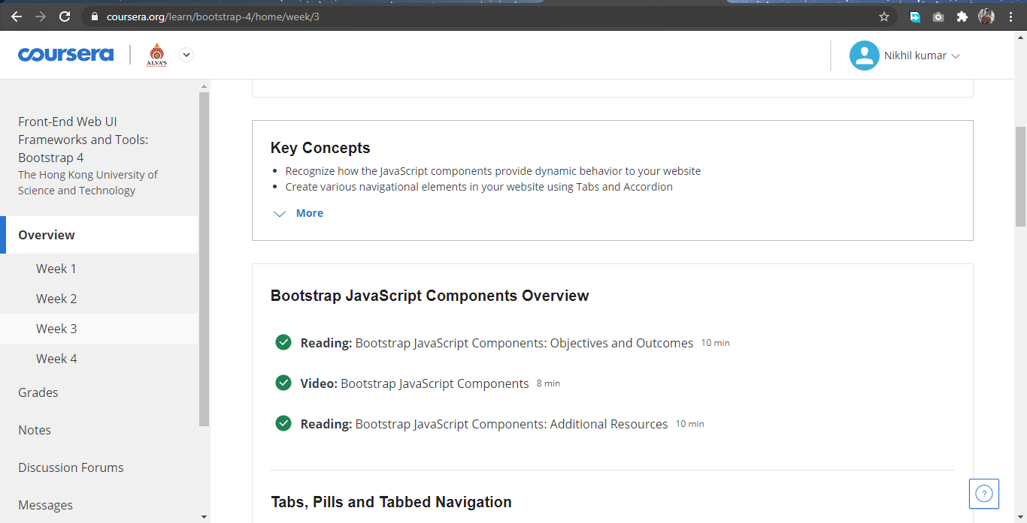Thank you.**